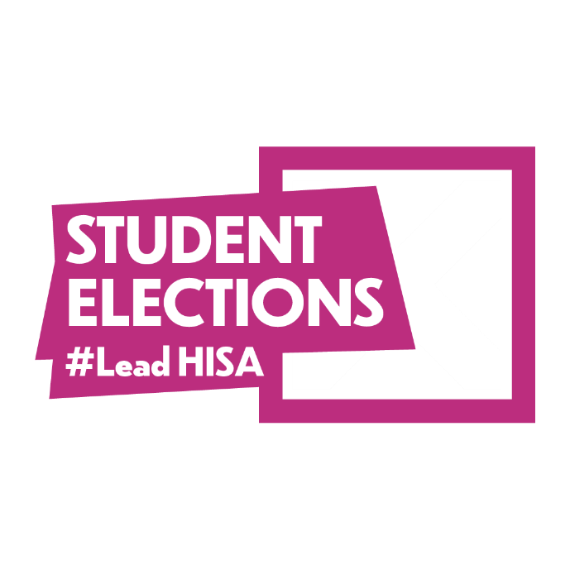
Policy Pledge S.W.O.T Analysis Worksheet
#LeadHISA
Policy Pledge Idea:

  Strengths
  Weaknesses
  Opportunities
  Threats

