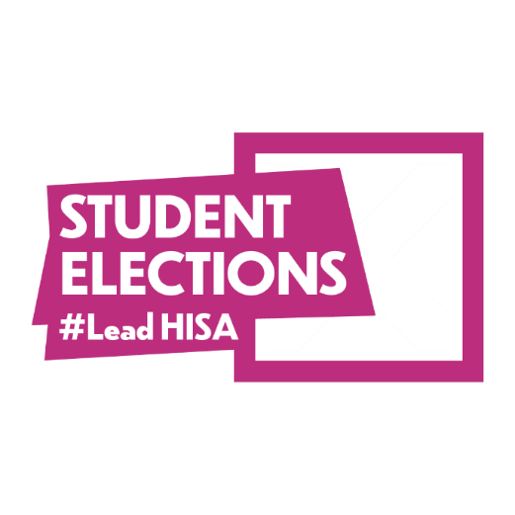

Elections Expenses Form

Your Details:

Name:
UHI Email:
Election: | 2025 Student Elections
Role:

Your Expenditure:

Please record here the details of all your campaign expenses (items and services) relating to your campaign.

Remember, except for items and services that are readily and freely available to all, everything you use for your campaign must be recorded on
your Election Expenses Form, whether you have purchased it or not.

Item / Service | Details | Cost | Receipt
 |  |  | ☐
 |  |  | ☐
 |  |  | ☐
 |  |  | ☐
 |  |  | ☐
 |  |  | ☐


Item / Service | Details | Cost | Receipt
 |  |  | ☐
 |  |  | ☐
 |  |  | ☐
 |  |  | ☐
 |  |  | ☐
 |  |  | ☐
 |  |  | ☐
 |  |  | ☐

Remember to send copies of your receipts with your Election Expenses Form. HISA can only reimburse Election Expenses where a receipt or proof of purchase has been provided.

Your Bank Details:

Bank Name:
Sort Code:
Account Number:

Please Note: By submitting this form, you are declaring the information on this form is correct. Failure to submit correct the information could lead to you being removed from the election.

Election Expenses Forms must be submitted to elections.hisa@uhi.ac.uk by 5pm Thursday 13th March 2025.

